VIETNAM NATIONAL UNIVERSITY,

HCMC UNIVERSITY OF TECHNOLOGY

FACULTY OF COMPUTER SCIENCE AND ENGINEERING



**SOFTWARE ENGINEERING (CO3001)**

URBAN WASTE COLLECTION AID

UWC 2.0

Task 2**: System Modeling**

|  |  |
| --- | --- |
| **Professors** | |
| Bùi Hoài Thắng & Nguyễn Đức Anh | |
|  | |
| **Members** | |
| Trần Phạm Minh Đăng | 2052070 |
| Ngô Trương Trọng Nghĩa | 2053264 |
| Đinh Xuân Quang | 2053359 |
| Nguyễn Hoàng Thuận | 2052729 |
| Nguyễn Trấn Quốc | 2053384 |

Ho Chi Minh city, March 2023

# **Draw an activity diagram to capture the business process between systems and the stakeholders in Task Assignment module**

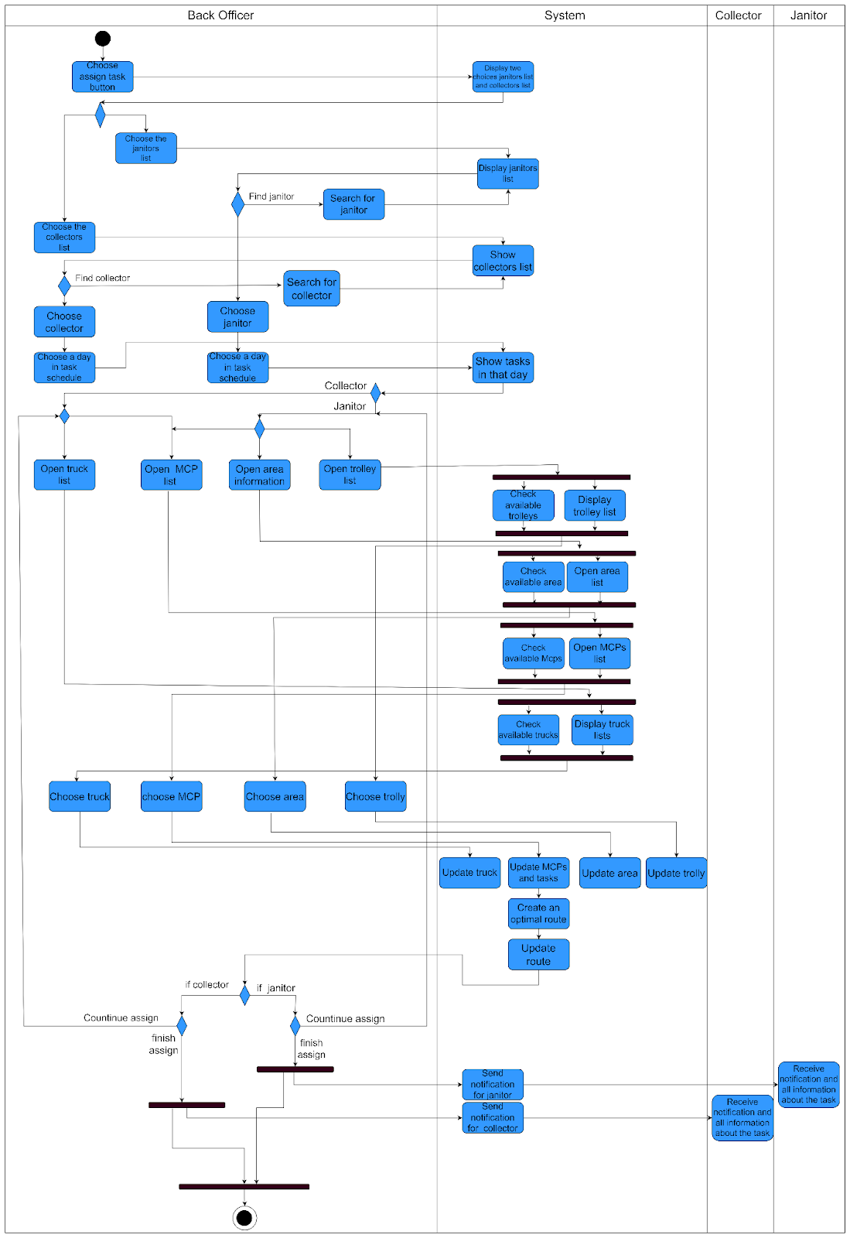

Firstly, back officers choose to assign tasks, then the system displays two choices: janitors and collectors.

For choosing the collectors:

* The system will display the list of collectors. Back officer can search for collectors and click on the desired collector to see information.
* The back officers choose a day in the task scheduler.The system shows the tasks on that day.
* Back officer starts assigning the MCPs to the collector by opening the MCPs information:
* The system will open an MCPs list then check MCP and update tasks, create and optimize routes and show the result to the back officer.
* Back officer starts assigning the trucks to the collector:
* The system will display the trucks list .Back officer chooses to assign the truck and update unavailable for the truck.
* After assigning MCPs or trucks, the back officer can choose to assign another task or finish the assignment . Then the system will send notification for collectors and finish.

For choosing the Janitors:

* The system will display the list of janitors. Back officer can search for janitors and click on the desired janitor to see information.
* The back officers choose a day in the task scheduler.The system shows the tasks on that day.
* Back officer starts assigning the MCPs to the collector by opening the MCPs information:
* The system will open an MCPs list then check MCP and update tasks, create and optimize routes and show the result to the back officer.
* Back officer starts assigning the trolleys to the collector:
* The system will display the trolleys list .Back officer chooses to assign the truck and update unavailable for the trolleys.
* After assigning MCPs or trucks, the back officer can choose to assign another task or finish the assignment . Then the system will send notification for collectors and finish.

# **Think about a possible way for a back officer to assign vehicles to janitors and collectors. Draw a sequence diagram to visualize this process**

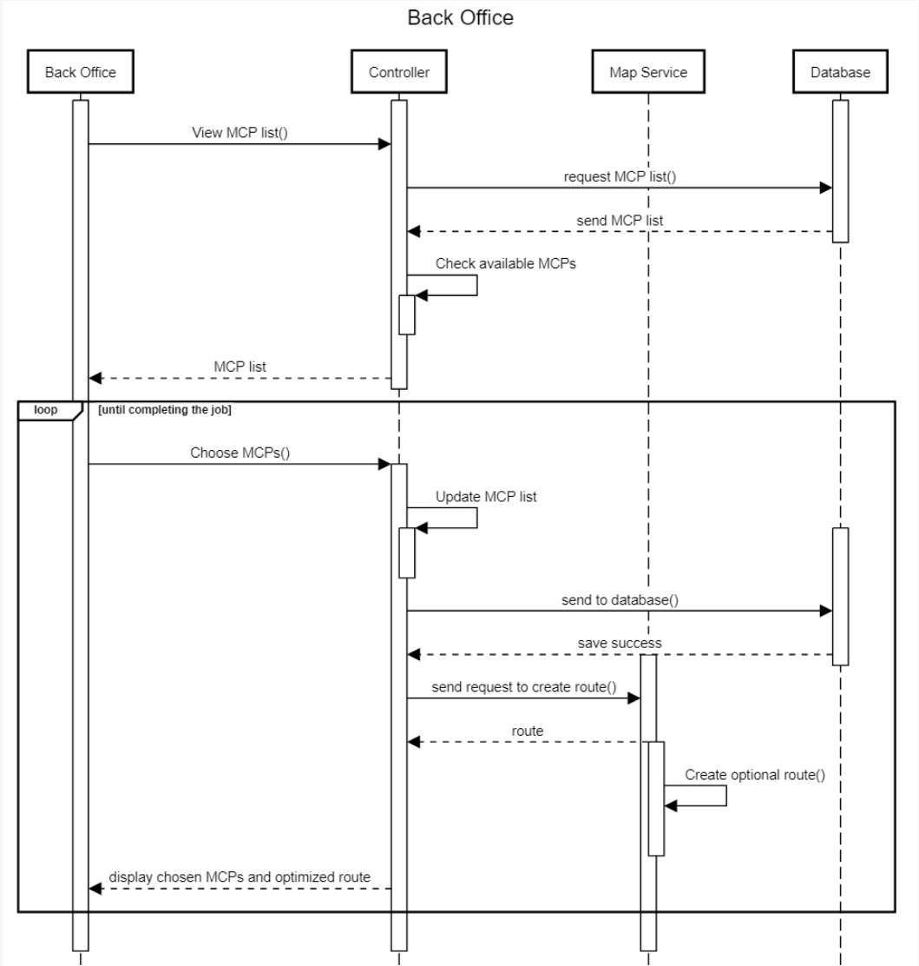

**Back Office:**

A list of the MCPs that are available is initially requested by the Back Office from the Controller, who then requests the data from the Database. The MCPs are chosen for the position and sent back to the Controller by the Back Office after being received. The MCP list is updated by the Controller and transmitted to the Database for storage. Additionally, the Controller asks the Map Service to build a route for the selected MCPs and send it back to the Back Office for display. The Back Office, Controller, Map Service, and Database all communicate continuously during the 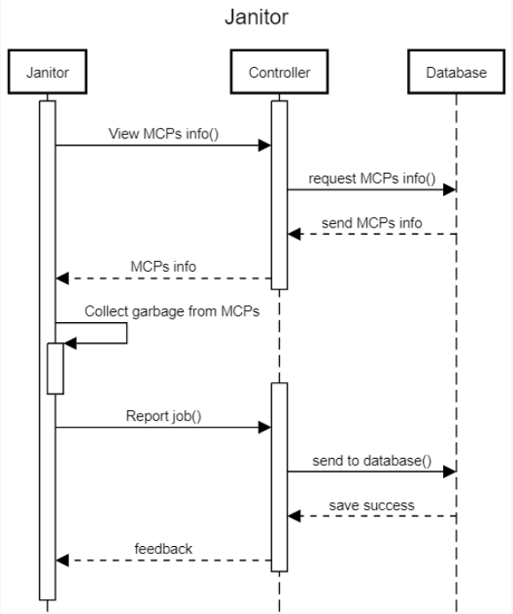process to guarantee effective MCP assignment and route optimization.

**Janitor:**

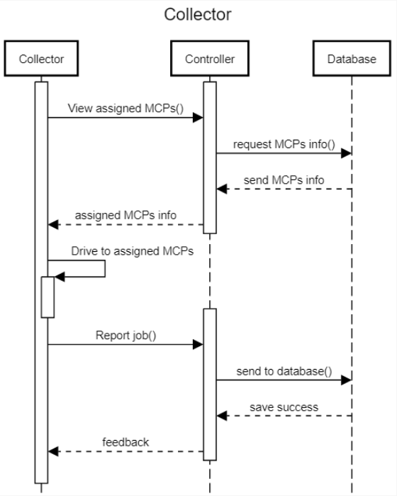A Janitor sends a request to the Controller in order to inspect the MCPs that are now available. The Controller then asks the Database for the MCP data and relays it to the Janitor. The Janitor can then remove trash from MCPs and notify the Controller that the task is finished. In addition to providing feedback to the Janitor, the Controller submits the report to the database.

**Collector:**

The Controller receives a request from a Collector asking to inspect the MCPs that are now available. The Controller then asks the Database for the MCP data and relays it to the Collector. The Collector chooses the car and inputs the MCP data. Next, after collecting trash from the MCPs and reporting the finished work to the Controller, they receive the optimized route from the Controller. The Controller transmits the information to the Database and notifies the Collector of any changes.

# **Draw a class diagram of Task Assignment module as comprehensive as possible.**

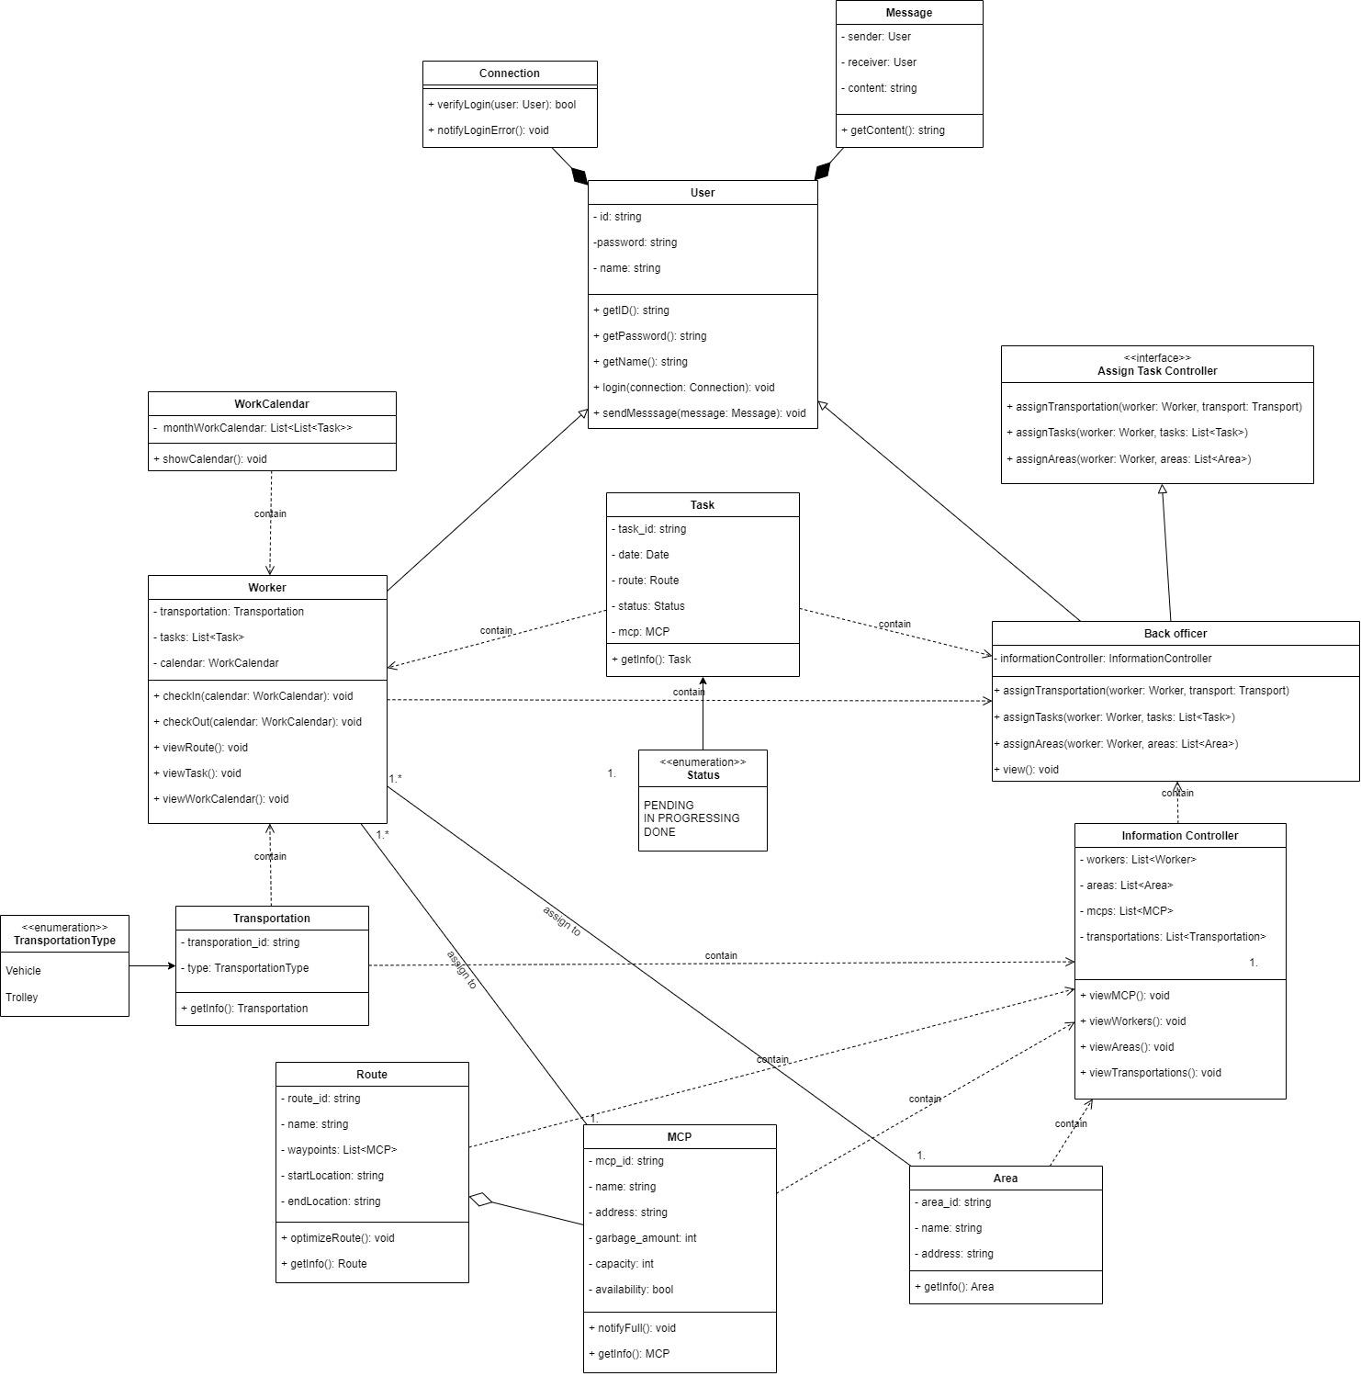

Users who are considered to be back officers, janitors, or collectors have information about their connections, such as an ID and a password.

The ability to assign MCP, area, transportation, and responsibilities to workers as well as view this information is available to back officers.

Collectors and janitors are categorized as workers. They can check in, check out, and track their tasks along with their progress.

Finally, everyone can message one another.

# **Develop MVP 1 as user interfaces of either a Desktop-view central dashboard for Task Management for back-officers OR a Mobile-view Task assignment for Janitors and Collectors. Decide yourself what to include in the view. Use a wireframe tool like Figma or Adobe XD, or Illustrator**

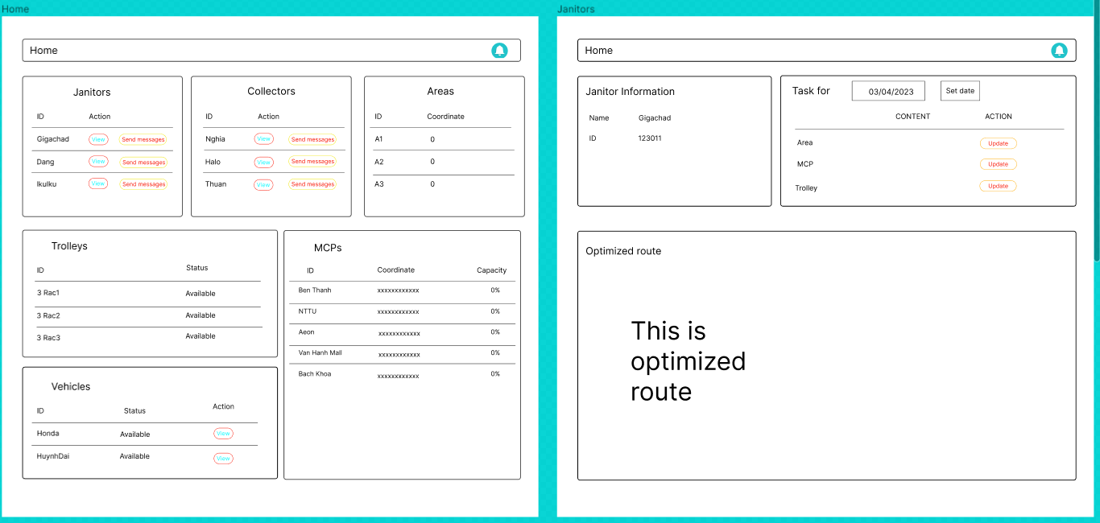We decided to use **Figma** as a wireframe tool to design an interface of a Desktop-view central dashboard for Task Management for back-officers.

Here is an overview of the design that we originally envisioned. The Home interface provides all of the vital information, whereas the Worker interface contains the information and what is required for job assignment.

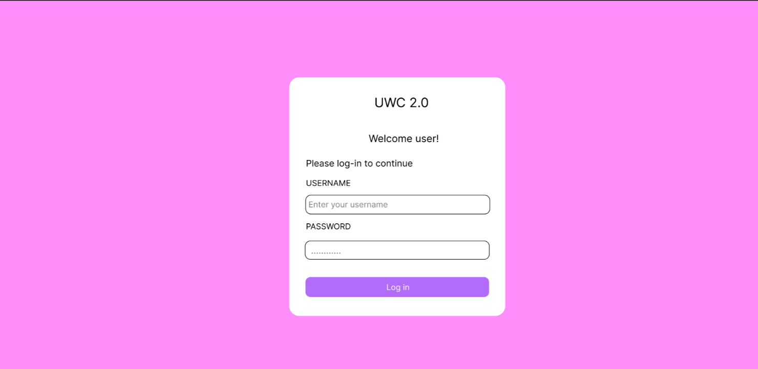Here is the ***Login*** interface:

The login interface includes a username, a password, and a login button that is necessary to verify identification.

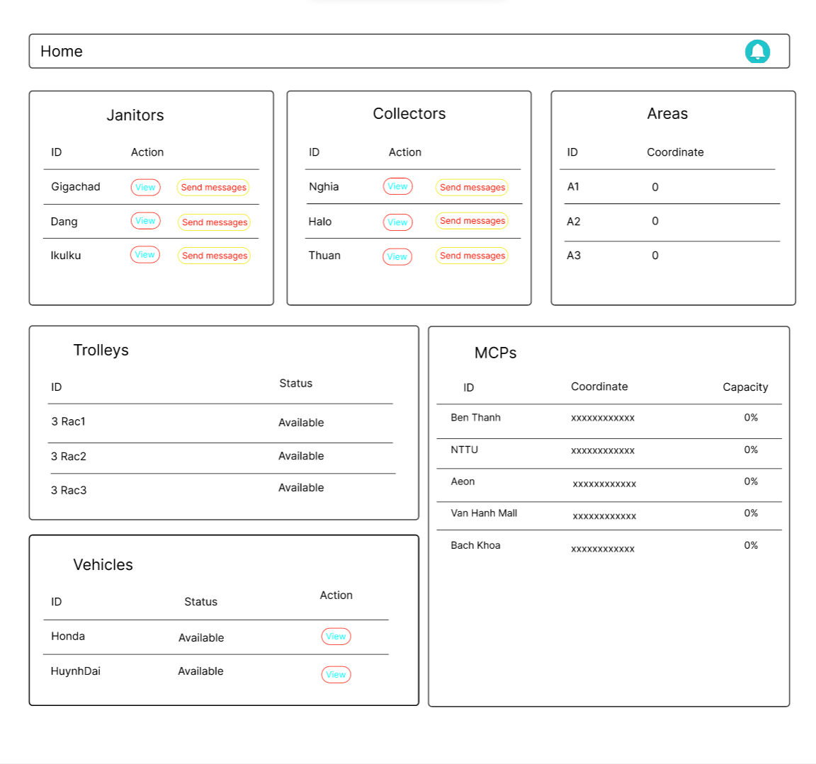The home interface will be presented upon successful login confirmation:

Our design conveys all relevant information while being succinct. Back officers may see the status of vehicles, the capacity of the MCP, and the workers allocated to that MCP all in one place. We feel it is more convenient than switching pages to view each piece of information.

When we conduct an interaction, this interface decreases the amount of page navigations. Consider the following work assignment procedure:

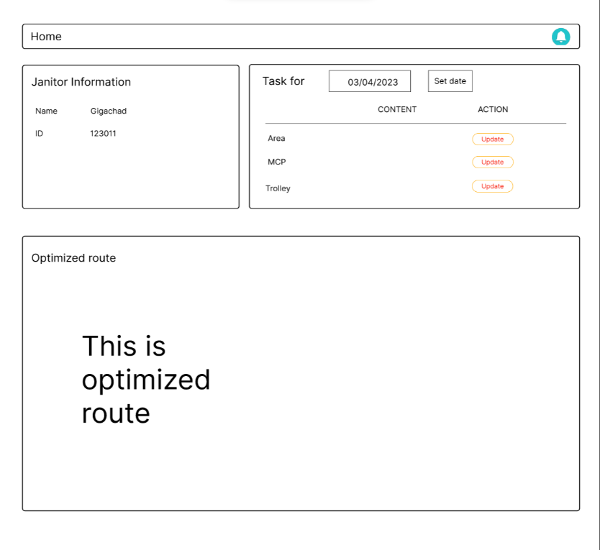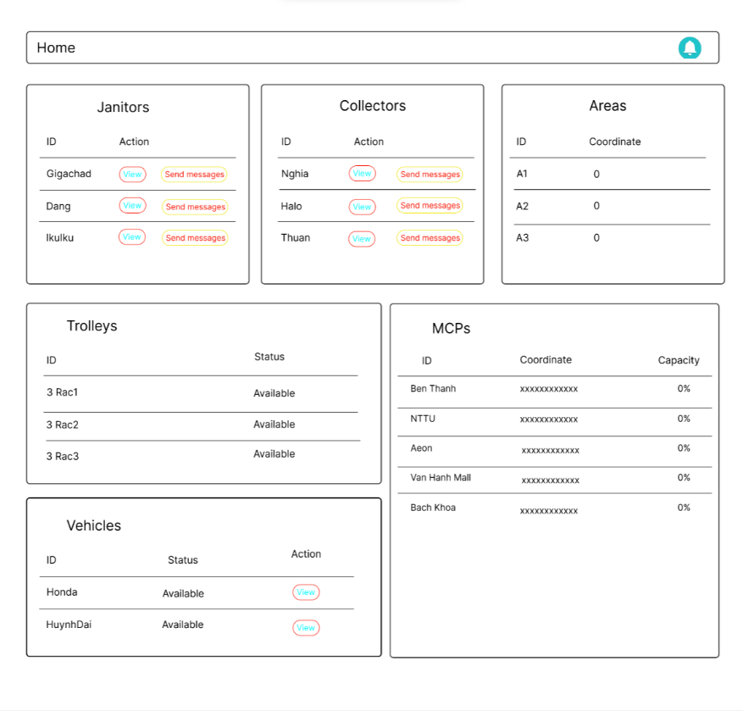

With this design, we can access all of the information about that worker, such as ID, status, optimal route, and some buttons to assign, change, and remove their assignment, with only one click from the Home page.

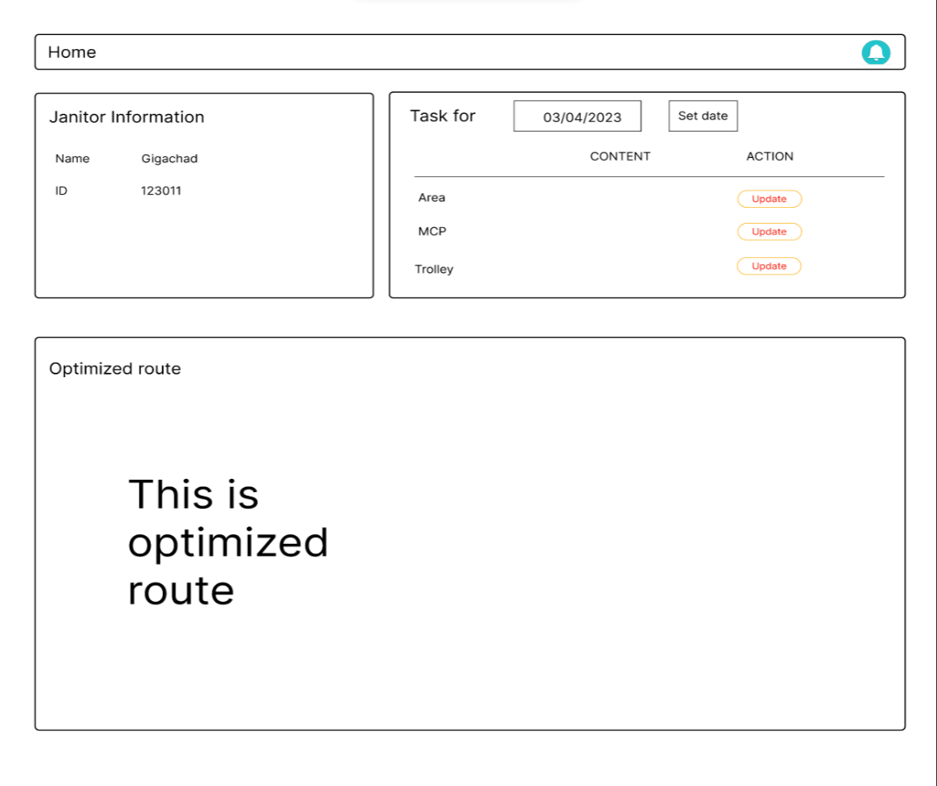Assigning jobs to Janitors entails assigning, updating, and removing Area, MCP, and Trolley as seen on the screen.

Collectors are assigned tasks using the same interface as Janitors. The main change is that Vehicles and MCPS must be assigned, updated, and deleted instead:

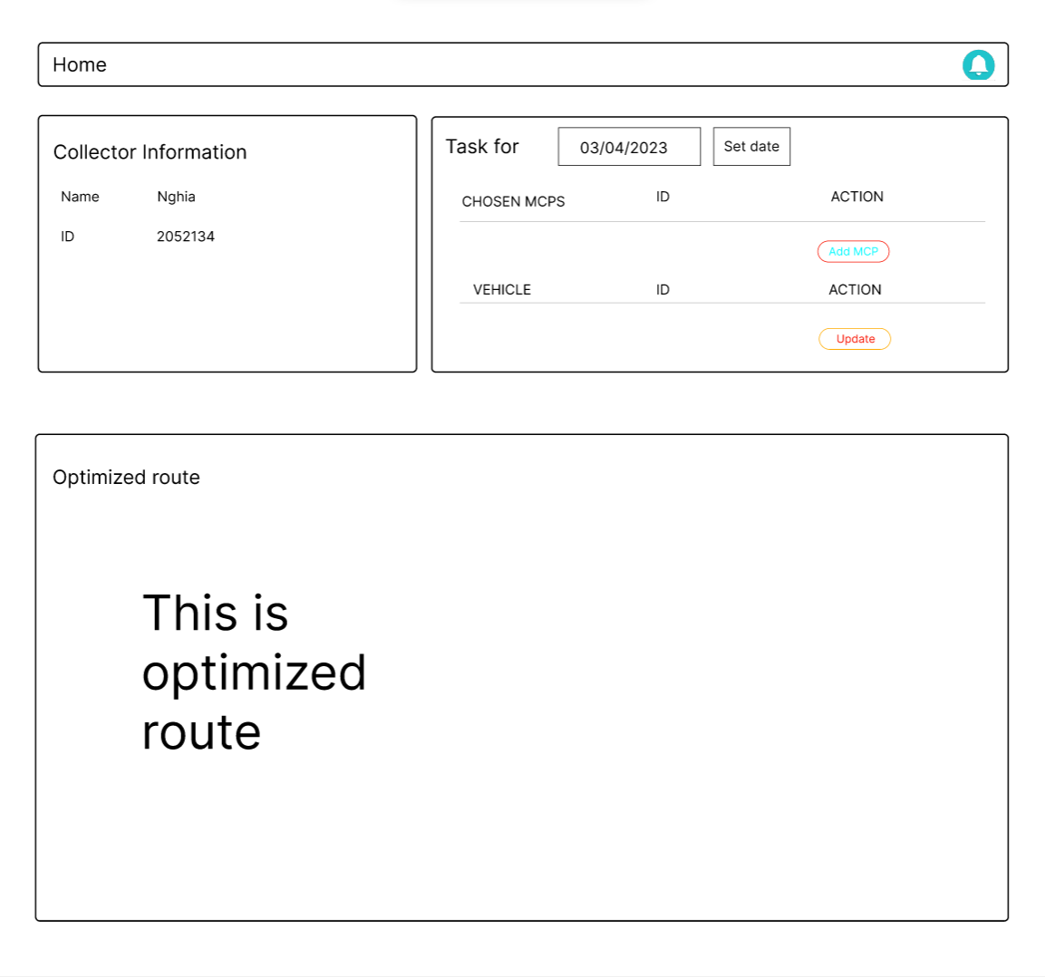When you click the Update button, a modal with the assigning section will appear. The graphic below, for example, depicts the mode for allocating Vehicle:

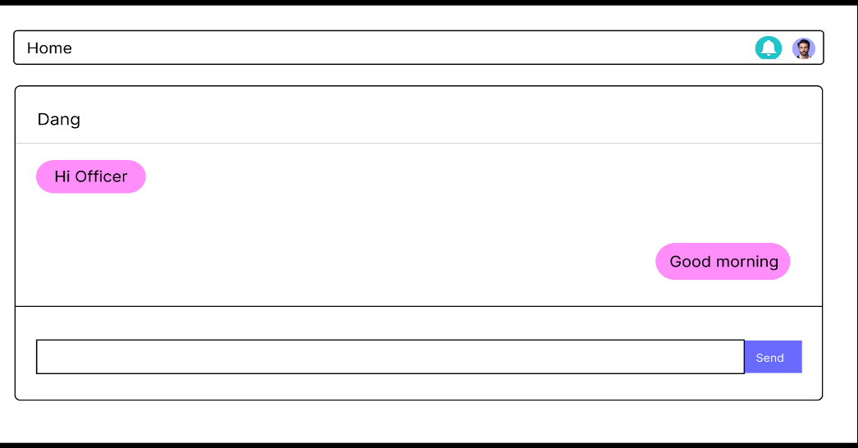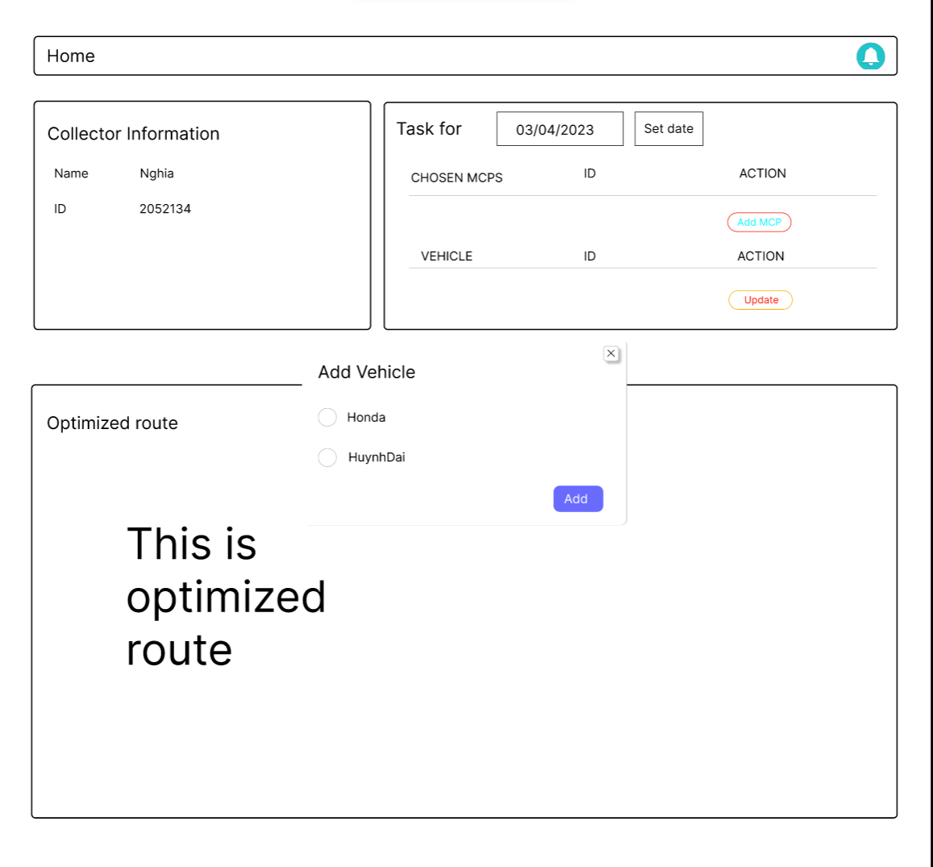This is the message sending interface. It includes the chat box and any communications exchanged between the back-officer and the selected worker:

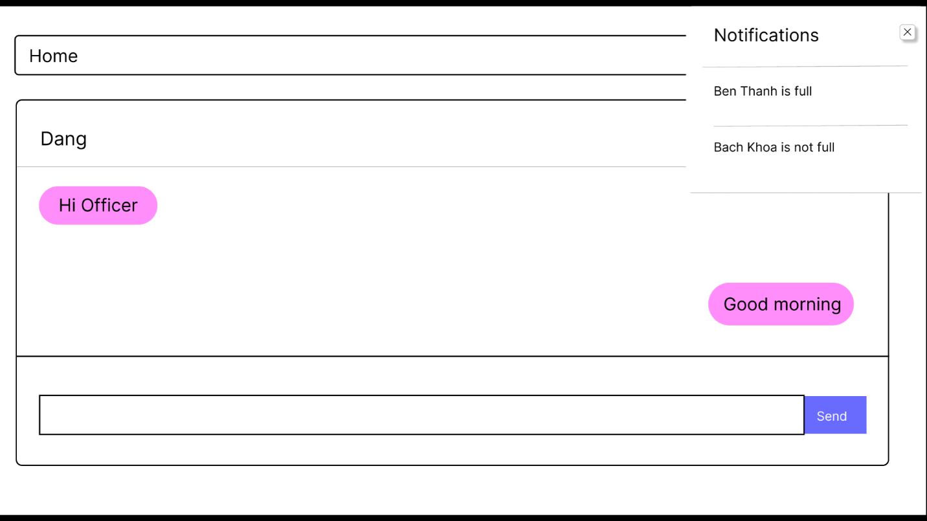Notices indicating the completeness of MCPs may always be seen in the upper right corner.

Overall, this approach enables us to swiftly allocate tasks to workers while maintaining a clear overview and the ability to adjust them effectively.